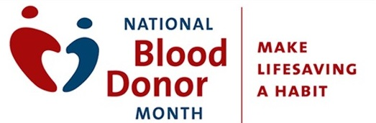

An Op-Ed, short for “opposite the editorial page”, is a written piece to be typically published by a newspaper, which expresses the opinion of the author and not affiliated with the publication’s editorial board.

We encourage you to send to your local media, partner organizations and anyone else that could help amplify the need for blood donors in January and throughout the year.
Op-Ed
January is National Blood Donor Month (NBDM), a month to focus on celebrating those blood donors who save lives and to inspire friends and family to become blood donors. Blood transfusions are the most frequent procedure performed in hospitals with more than 33,000 daily donations required to meet patient needs in the U.S. To ensure blood is available when needed, communities worldwide rely on the commitment of altruistic blood donors who empower blood centers to continue serving their communities through the availability of a safe and robust blood supply.
It is time to take action to promote blood donation and awareness of it throughout our communities to support the needs of patients.
In the last 10 years, there has been a significant decline in donor participation with far less than 10 percent of eligible individuals choosing to give blood even once per year. Donation frequency among 18-34 year-olds is far lower than previous generations, and additional diversity in the donor base is needed to meet patient needs.
Traditional efforts to recruit must evolve to meet changes that have occurred in technology, workplace environments (i.e. virtual workplaces increasing) and the increase of diversity of patients needing blood.
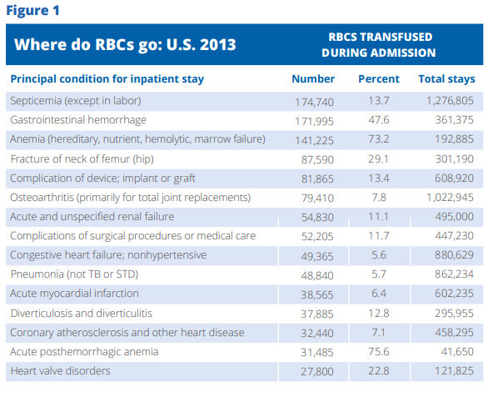
Source: America’s Blood Center Value of Blood Whitepaper, 2019
Ensuring a safe and available blood supply will take a concerted effort of community attention and as such, this is a plea for individuals, civic groups, corporations, and others to re-engage and join us in promoting this vital resource.
Please thank those who donate blood for their commitment to saving lives and encourage those around you to become blood donors. Area patients are counting on the support of their neighbors! You can make a difference for those in need.

